EXPREMENT-1

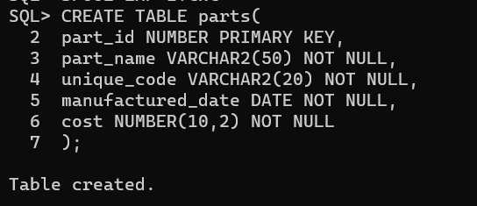

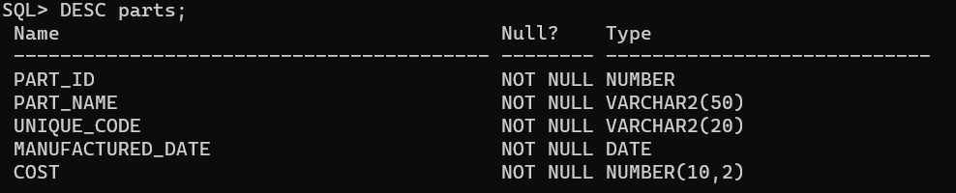

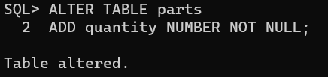

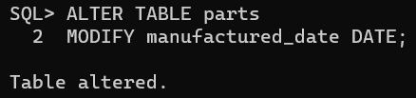

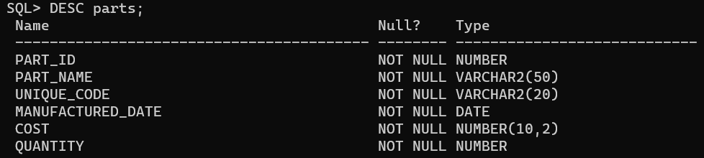

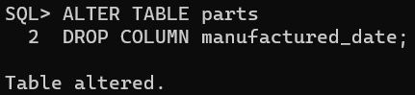

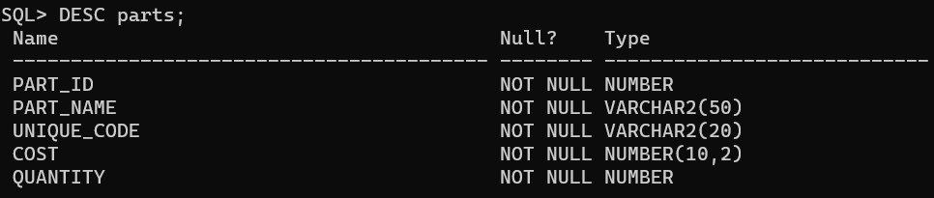

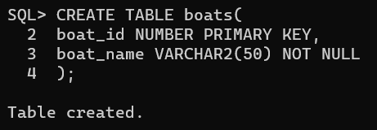

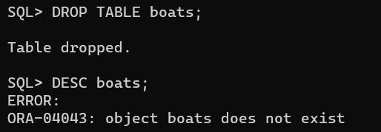

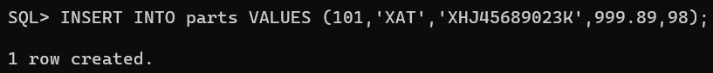

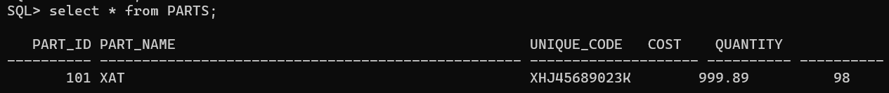

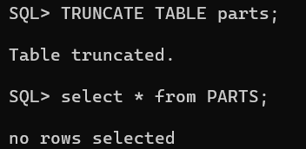

CONCLUSION:

SQL queries to CREATE TABLES for various databases using DDL commands (i.e., CREATE, ALTER, DROP, TRUNCATE) is successfully completed.

EXPREMENT-2

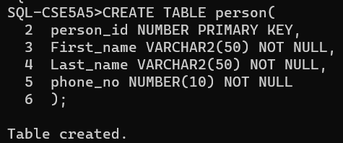

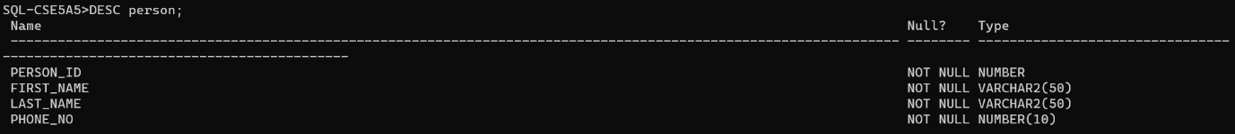

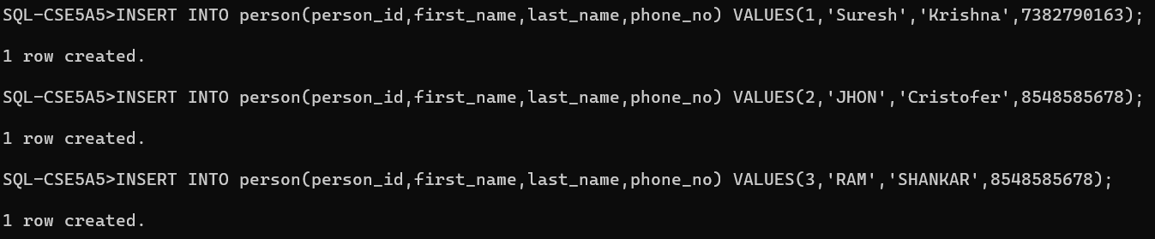

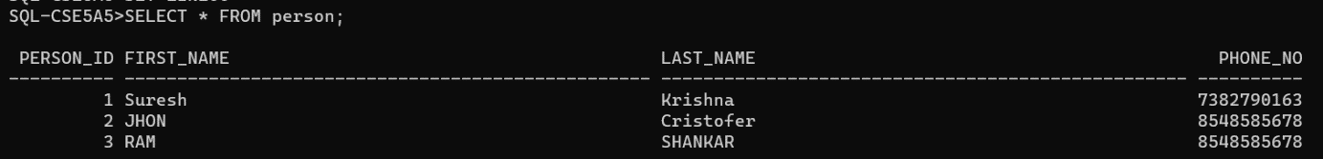

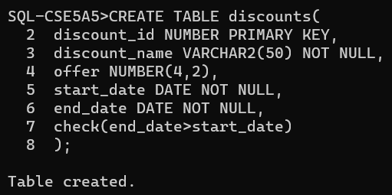

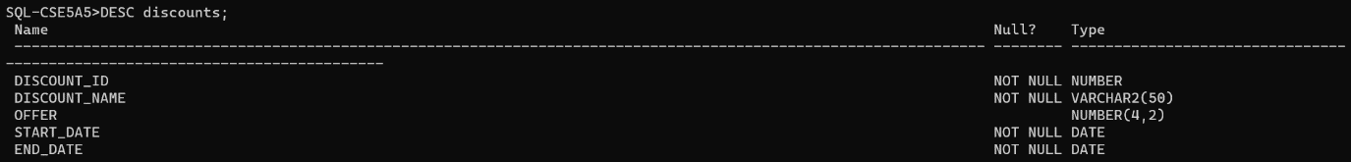

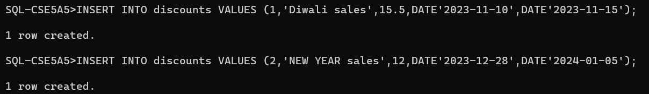

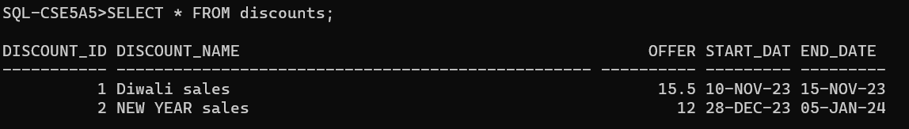

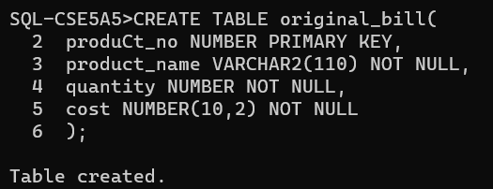

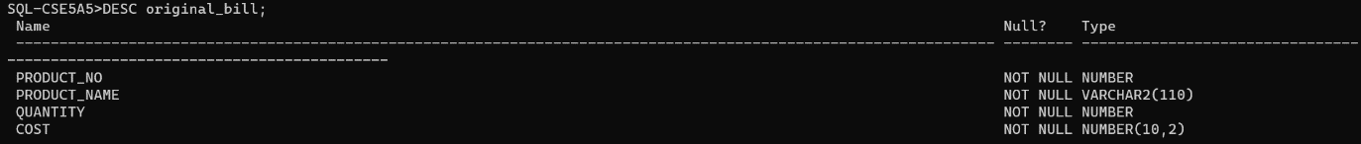

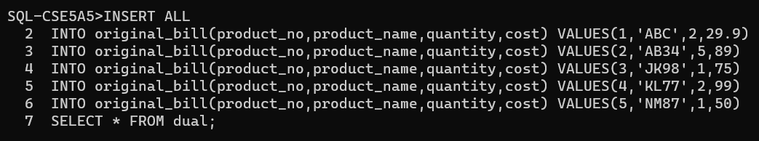

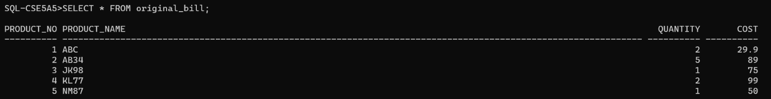

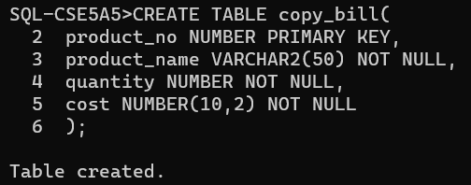

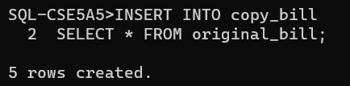

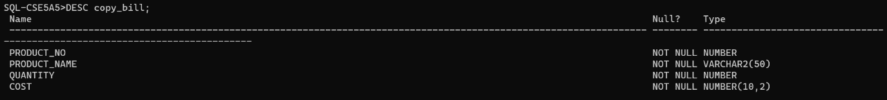

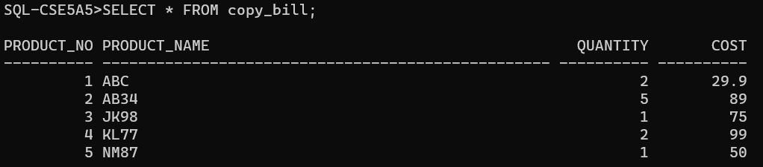

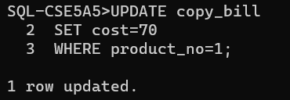

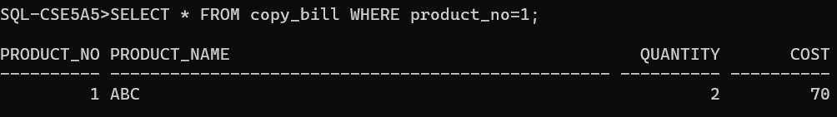

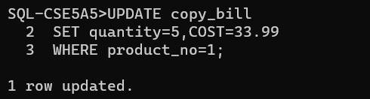

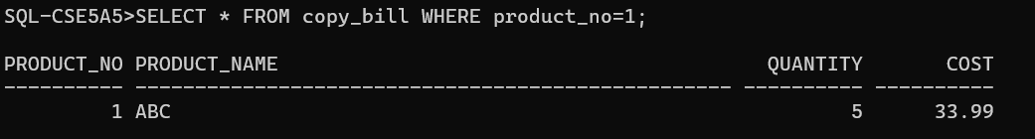

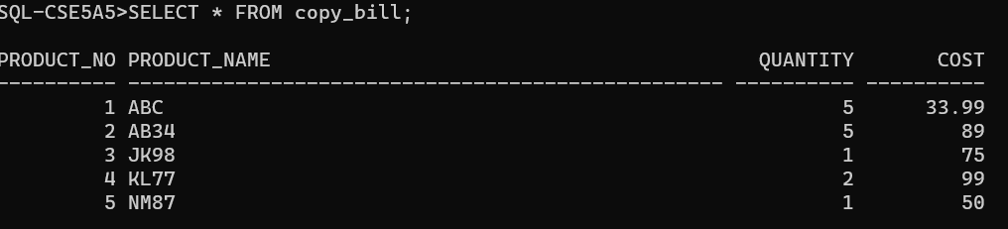

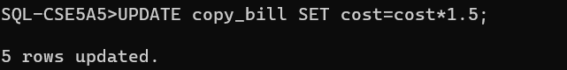

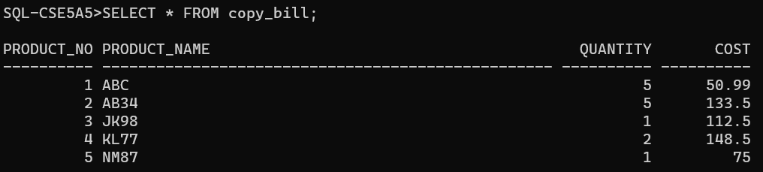

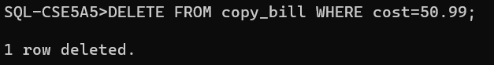

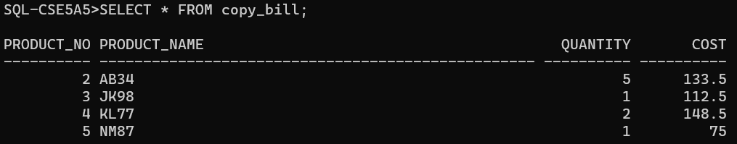

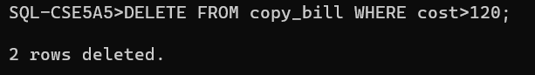

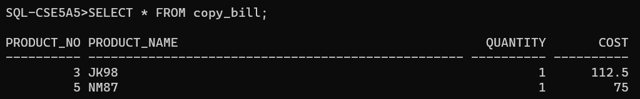

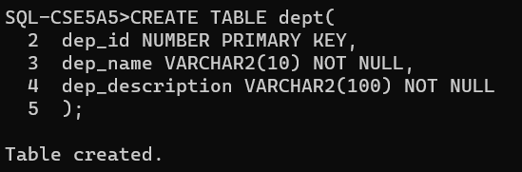

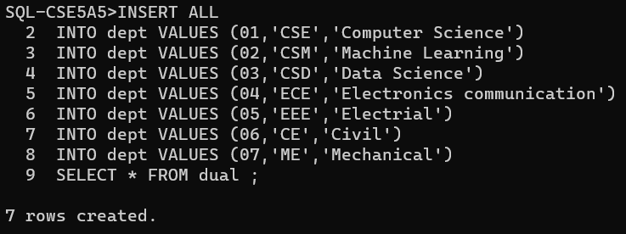

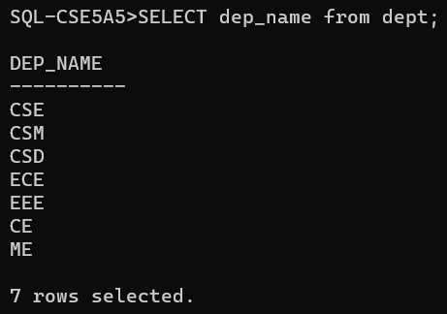

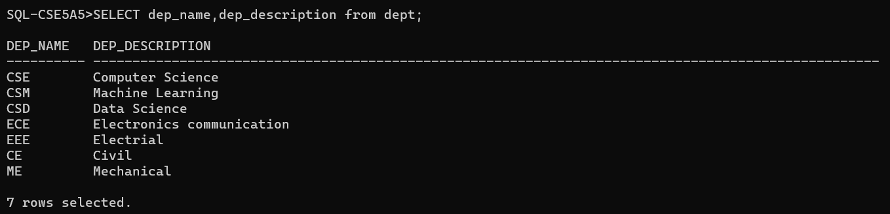

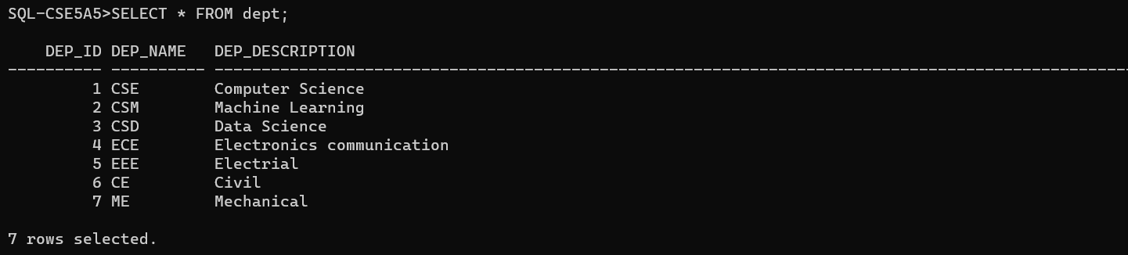

CONCLUSION:

SQL queries to MANIPULATE TABLES for various databases using DML commands (i.e., INSERT, SELECT, UPDATE, DELETE) is successfully completed.

EXPREMENT-3

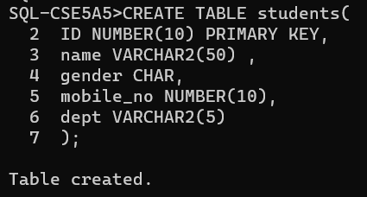

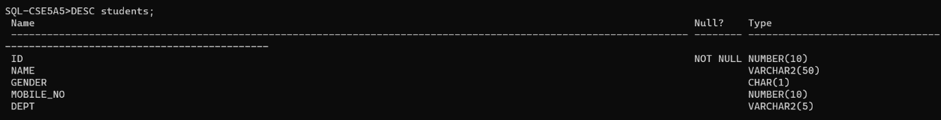

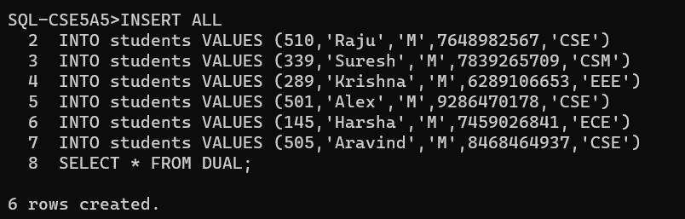

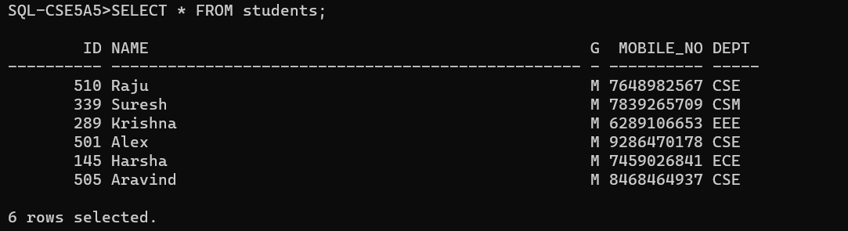

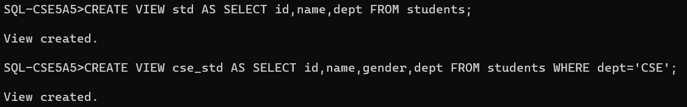

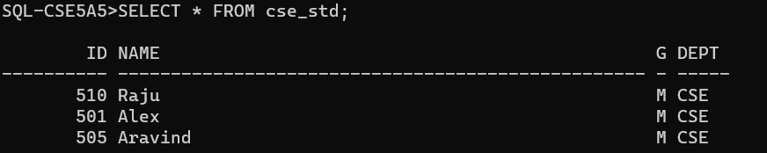

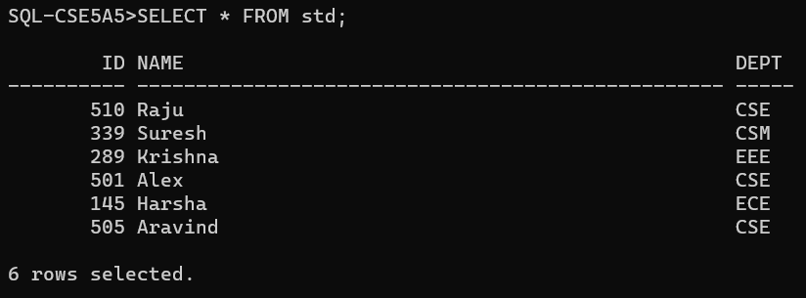

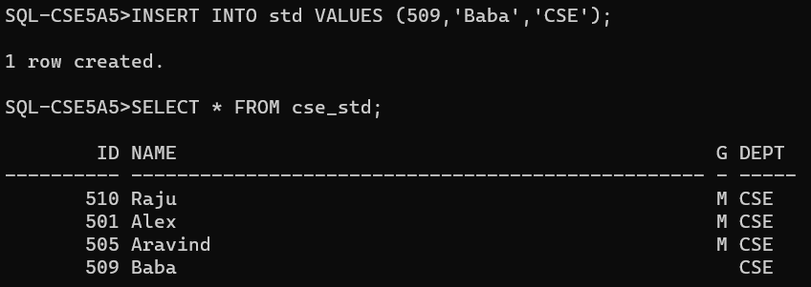

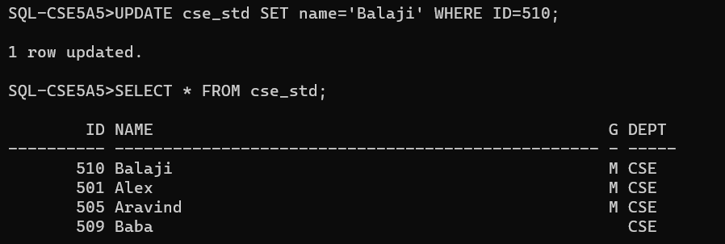

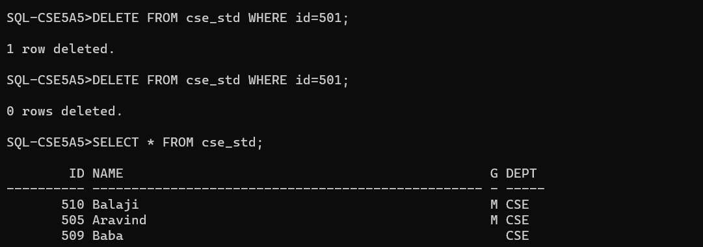

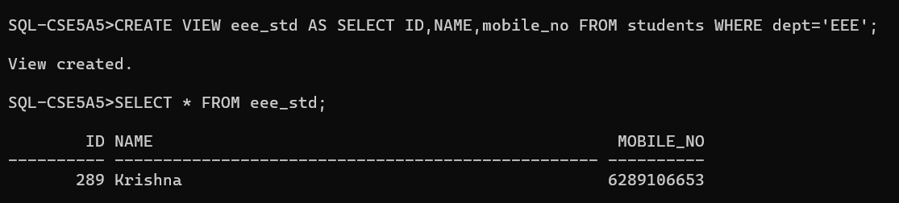

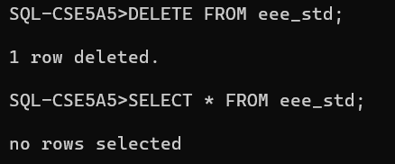

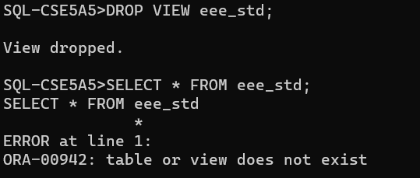

CONCLUSION:

SQL queries to create VIEWS for various databases (i.e., CREATE VIEW, UPDATE VIEW, ALTER VIEW, and DELETE VIEW) is successfully completed.

EXPREMENT-4

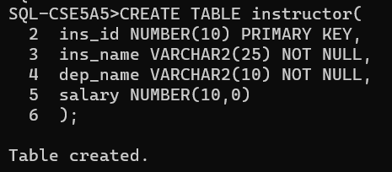

1. 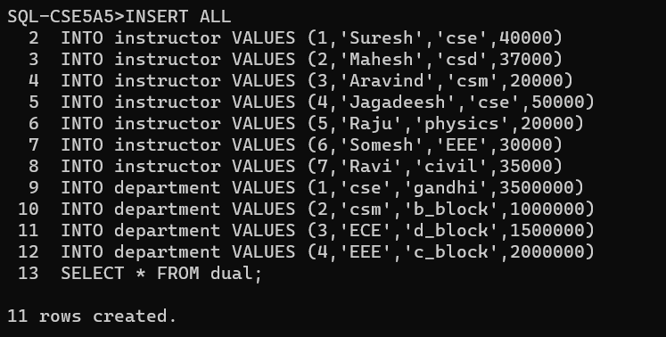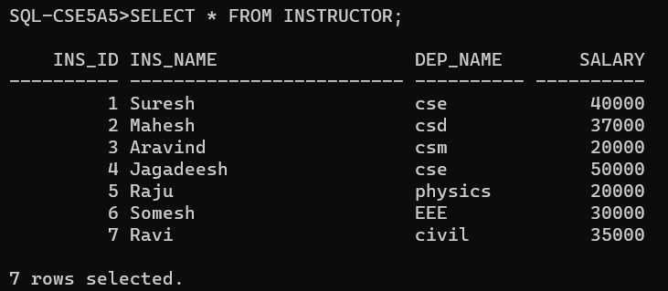

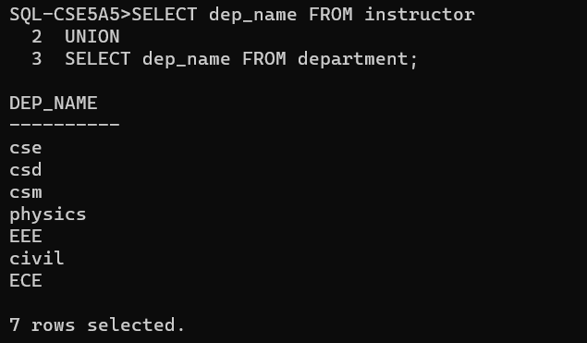

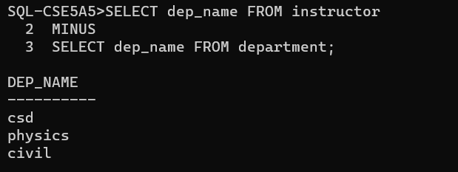

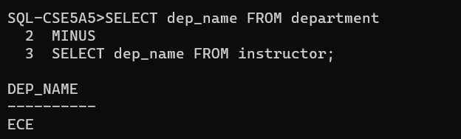

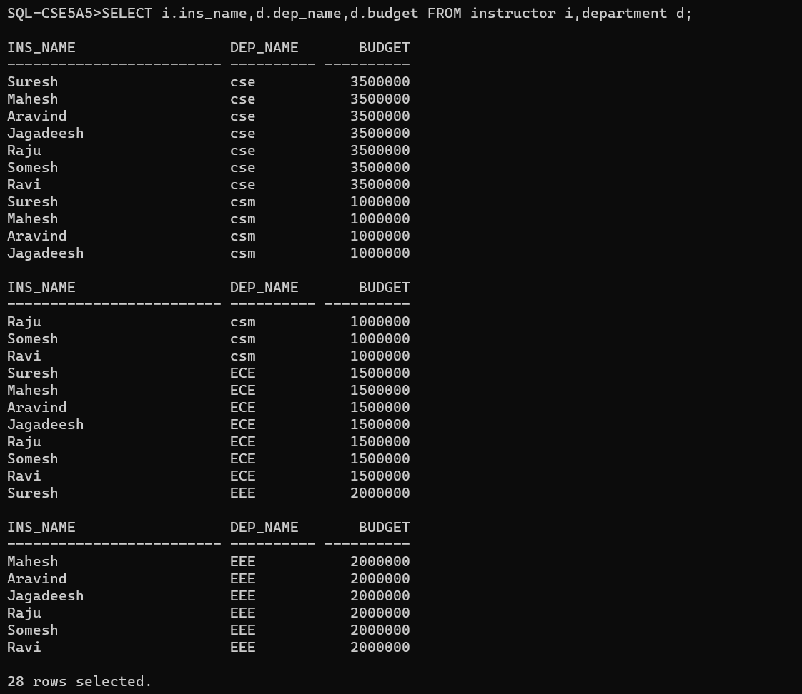

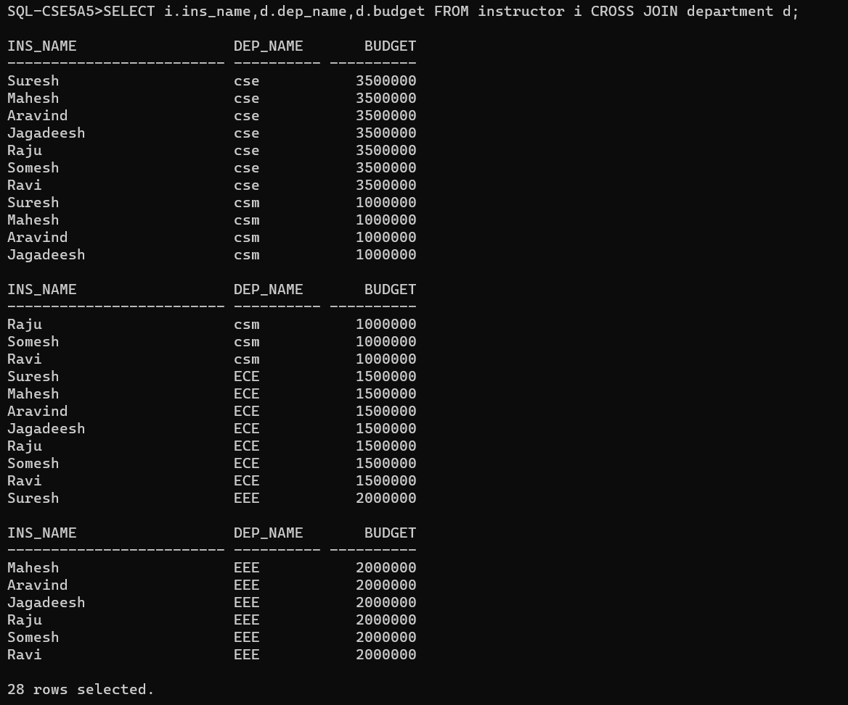

CONCLUSION:

SQL queries to perform RELATIONAL SET OPERATIONS (i.e., UNION, UNION ALL, INTERSECT, MINUS, CROSS JOIN, NATURAL JOIN) is successfully completed.

EXPREMENT-5

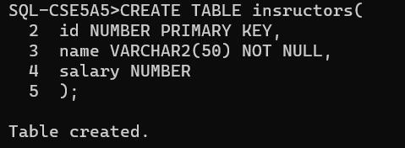

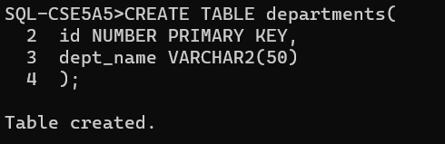

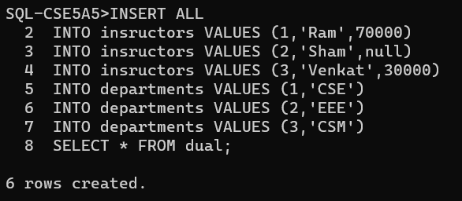

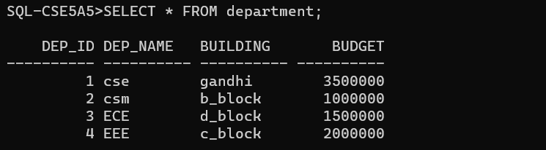

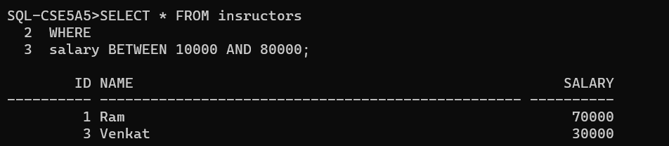

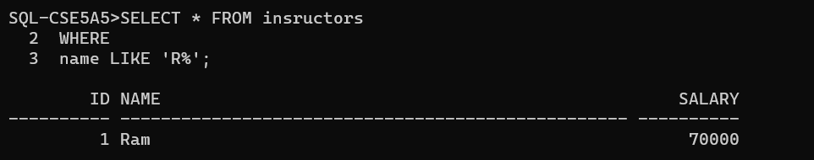

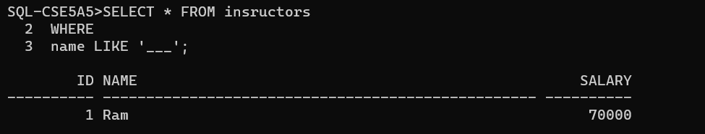

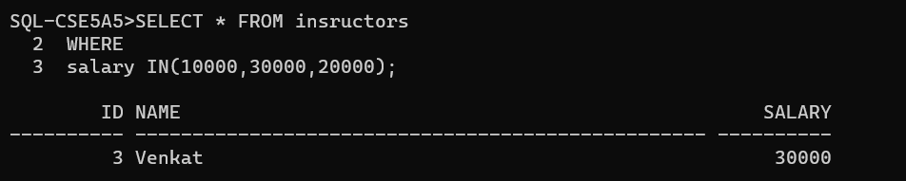

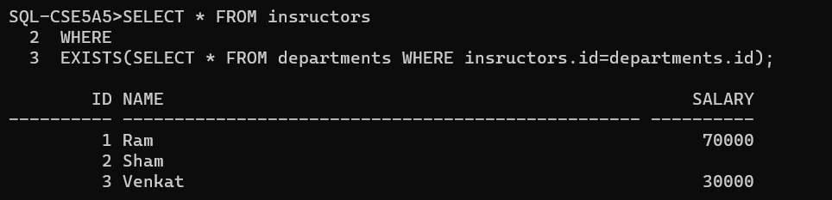

CONCLUSION:

SQL queries to perform SPECIAL OPERATIONS (i.e. ISNULL, BETWEEN, LIKE, IN, EXISTS) is successfully completed.

EXPREMENT-6

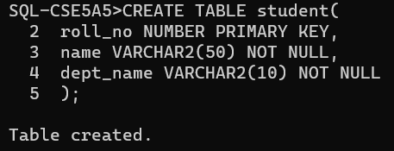

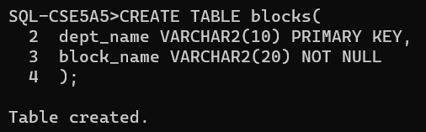

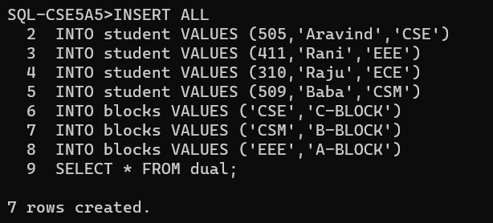

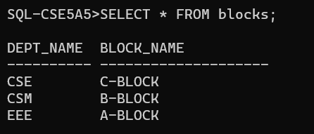

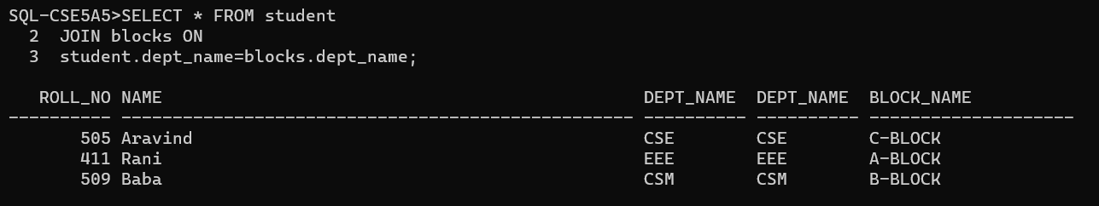

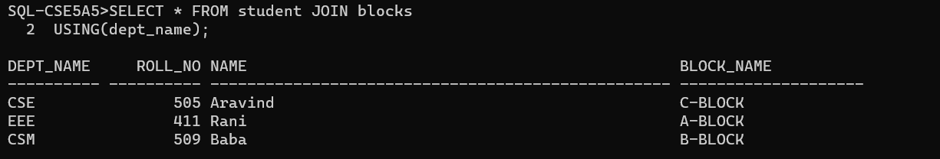

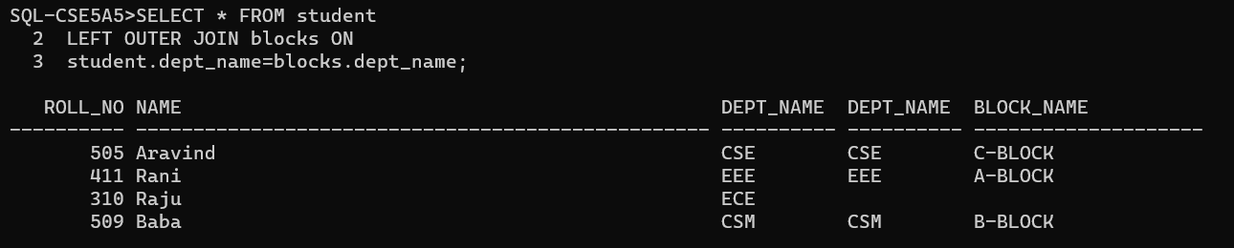

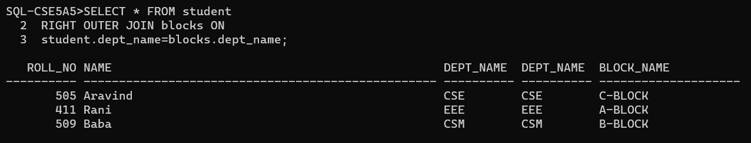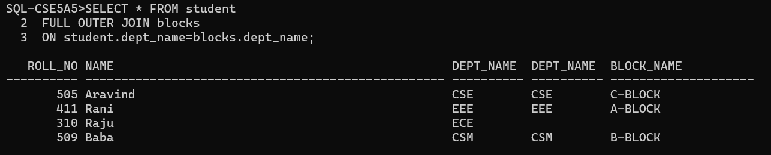

CONCLUSION:

SQL queries to perform JOIN OPERATIONS (i.e., CONDITIONAL JOIN, EQUI JOIN, LEFT OUTER JOIN, RIGHT OUTER JOIN, FULL OUTER JOIN) is successfully completed.

EXPREMENT-7

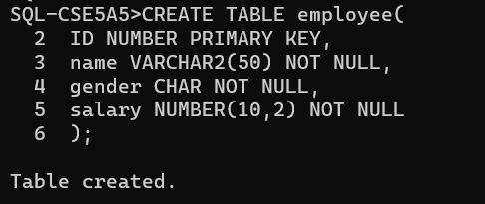

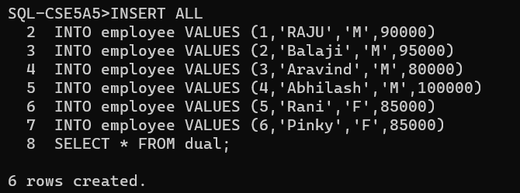

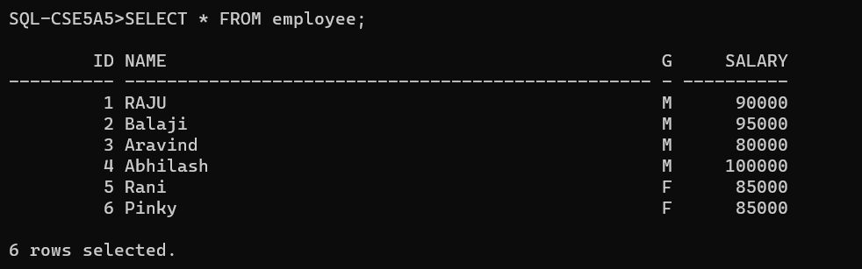

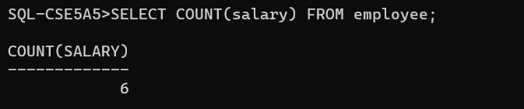

1. 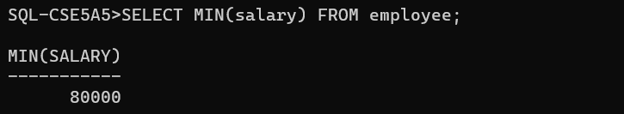

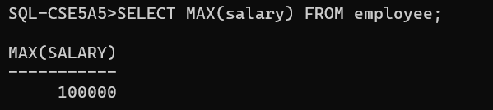

CONCLUSION:

SQL queries to perform AGGREGATE OPERATIONS (i.e., SUM, COUNT, AVG, MIN, MAX) is successfully completed.

EXPREMENT-8

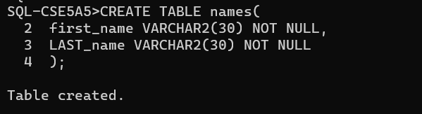

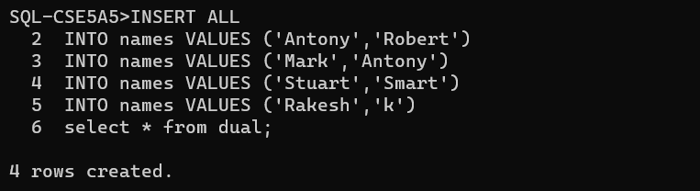

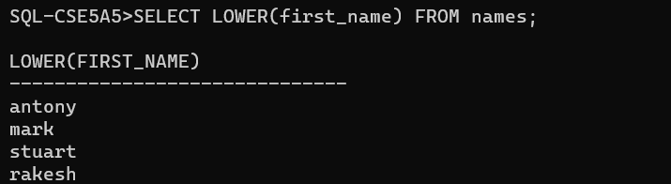

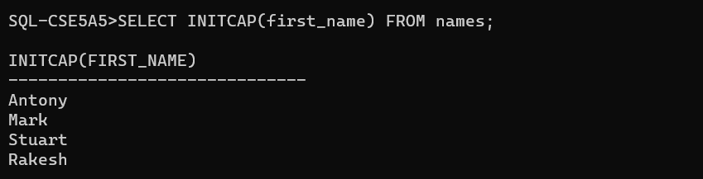

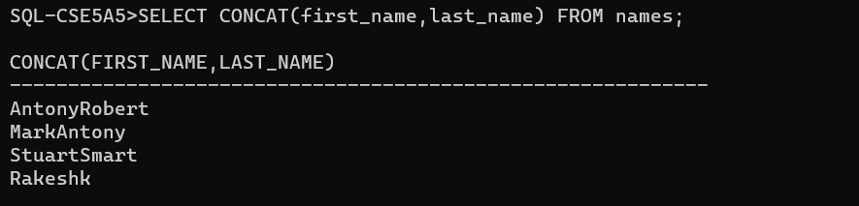

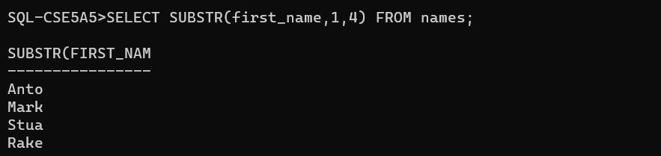

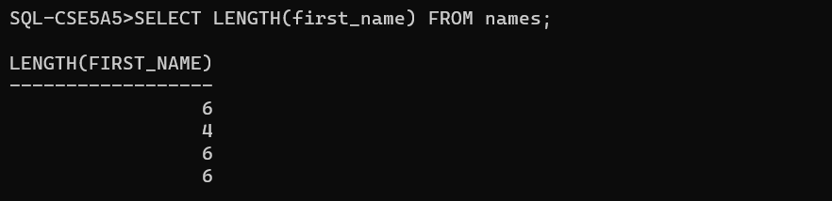

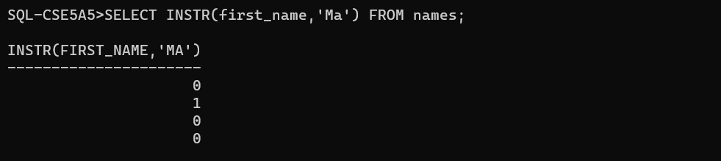

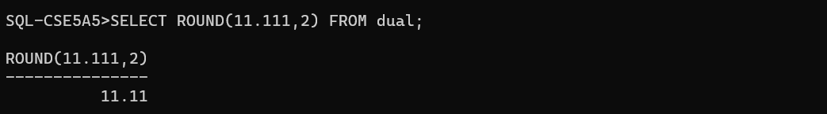

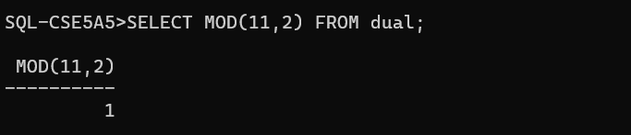

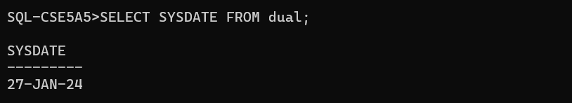

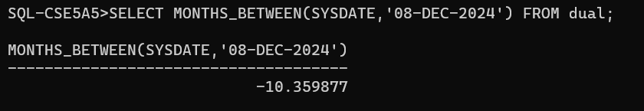

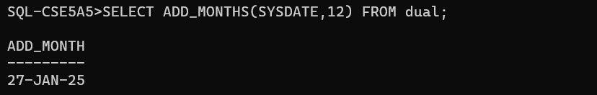

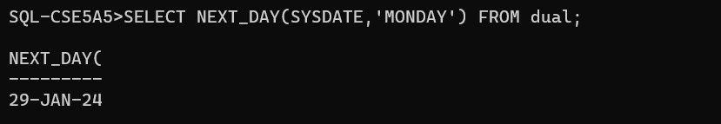

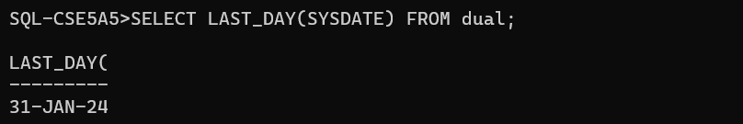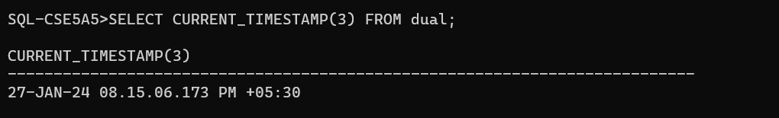

CONCLUSION:

SQL queries to perform ORACLE BUILT-IN FUNCTIONS (i.e., DATE, TIME) is successfully completed.

EXPREMENT-9

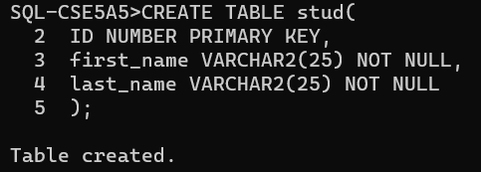

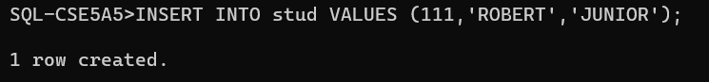

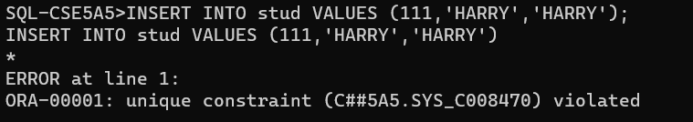

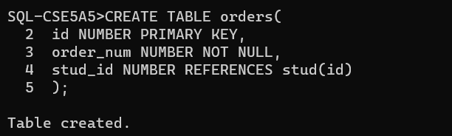

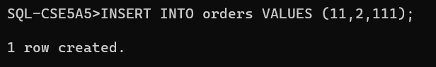

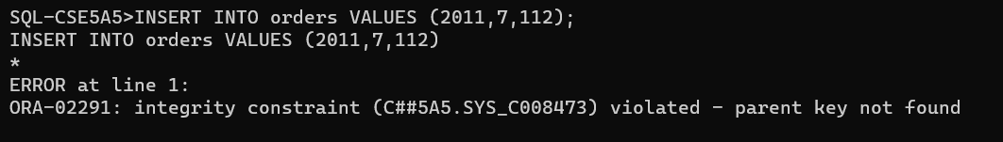

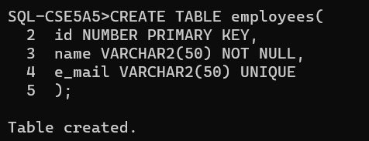



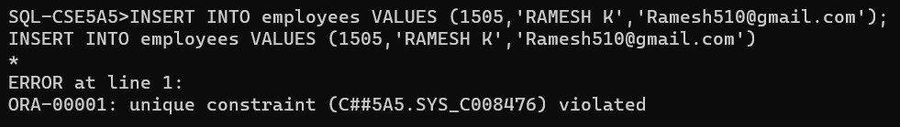

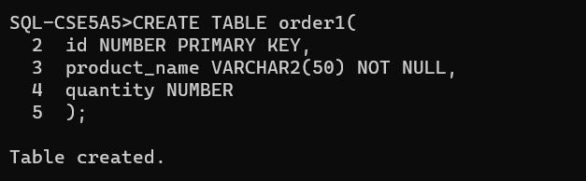

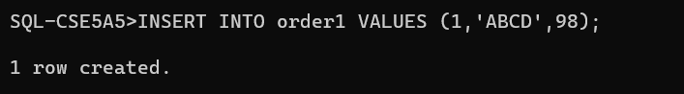

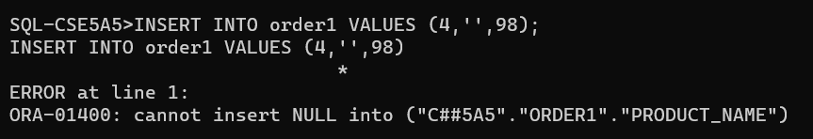

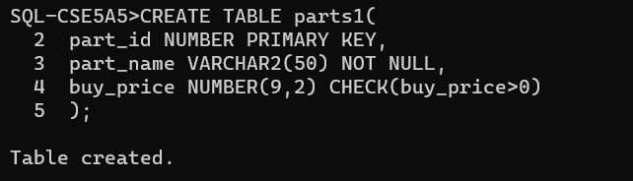

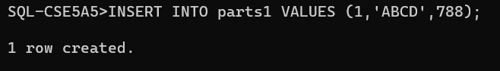

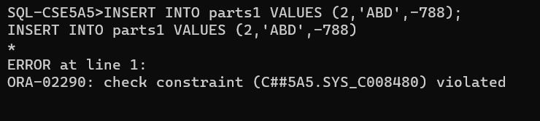

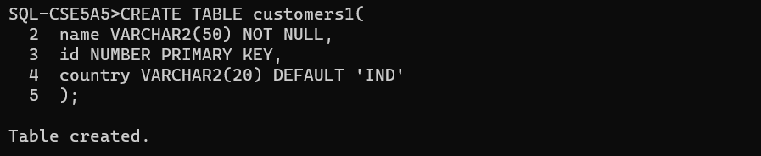

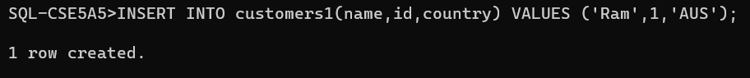

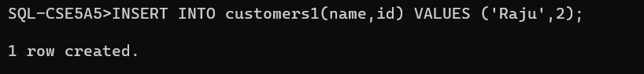

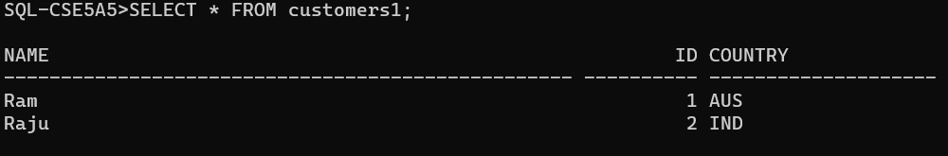

CONCLUSION:

SQL queries to perform KEY CONSTRAINTS (i.e., PRIMARY KEY, FOREIGN KEY, UNIQUE NOT NULL, CHECK, DEFAULT) is successfully completed.

EXPREMENT-10



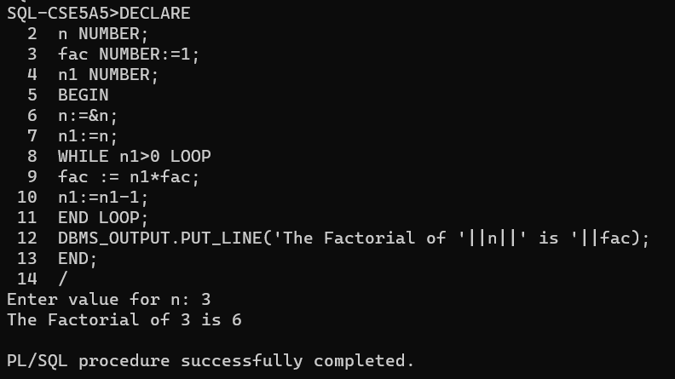

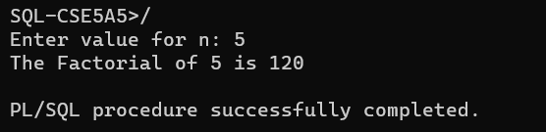

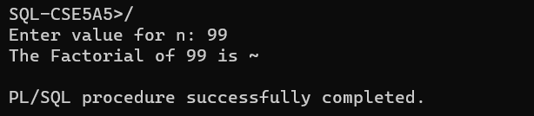

CONCLUSION:

PL/SQL program for calculating the factorial of a given number is successfully completed.

EXPREMENT-11



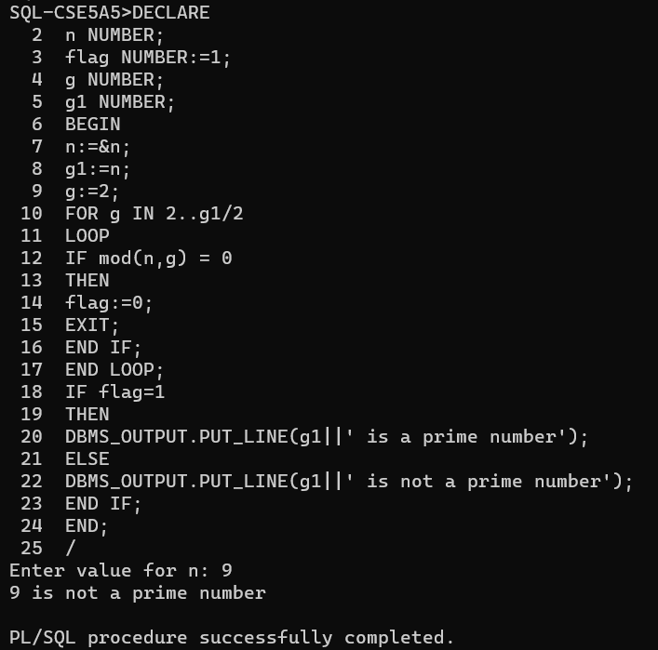

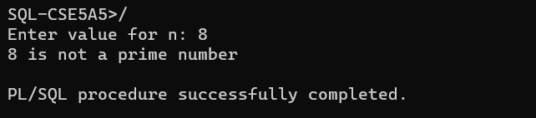

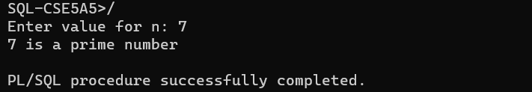

CONCLUSION:

PL/SQL program for finding the given number is prime number or not is successfully completed.

EXPREMENT-12



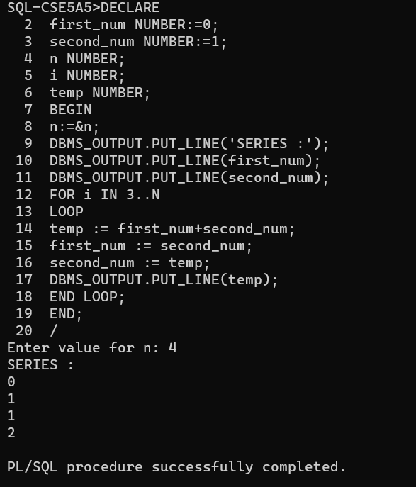

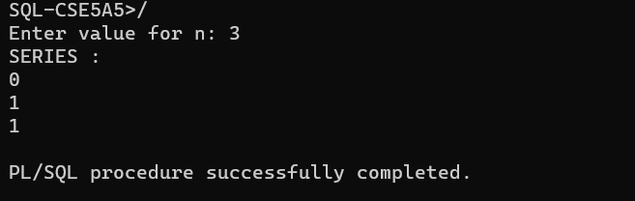

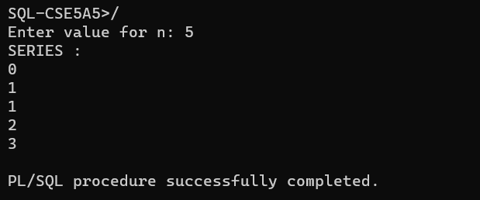

CONCLUSION:

PL/SQL program for displaying the Fibonacci series up to an integer is successfully completed.

EXPREMENT-13



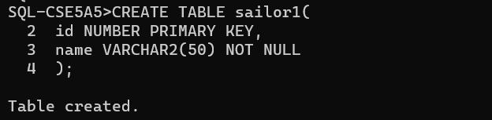

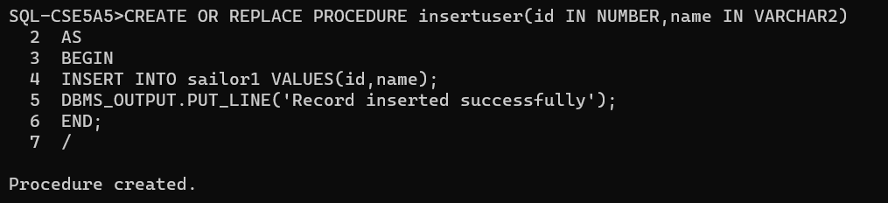

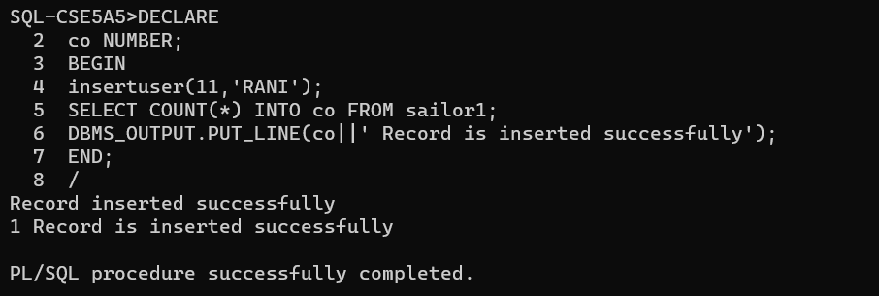

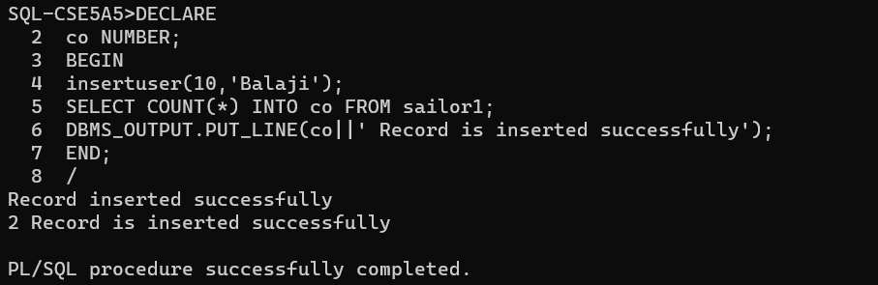

CONCLUSION:

PL/SQL program to implement Stored Procedure on table is successfully completed.

EXPREMENT-14



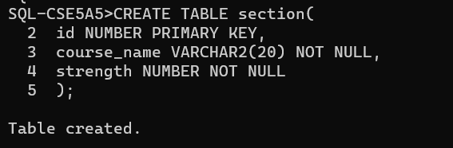

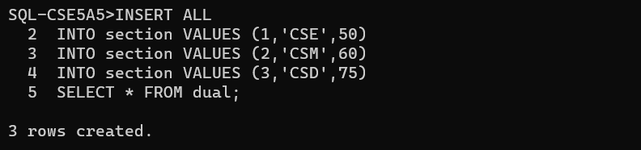

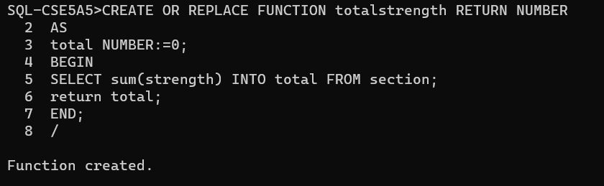

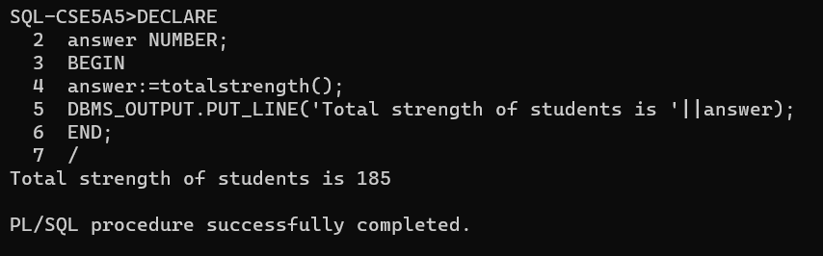

CONCLUSION:

PL/SQL program to implement Stored Function on table is successfully completed.

EXPREMENT-15



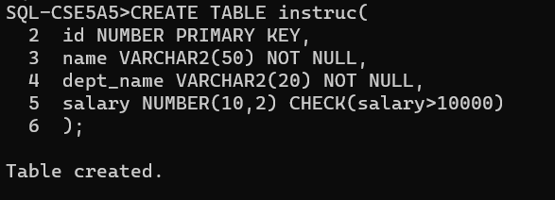

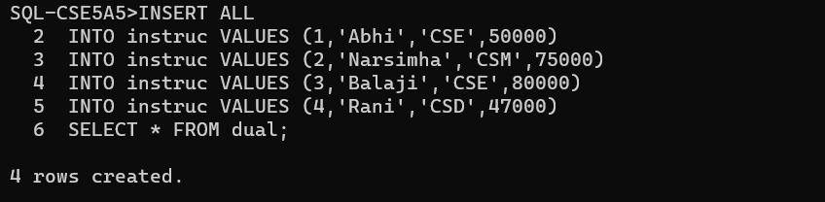

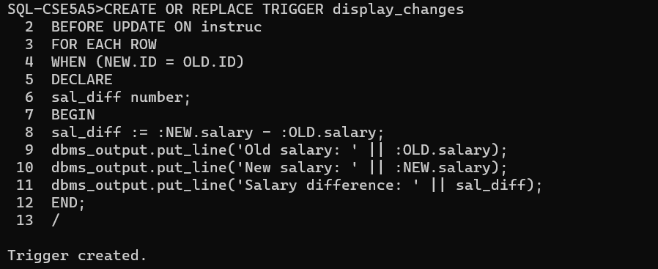

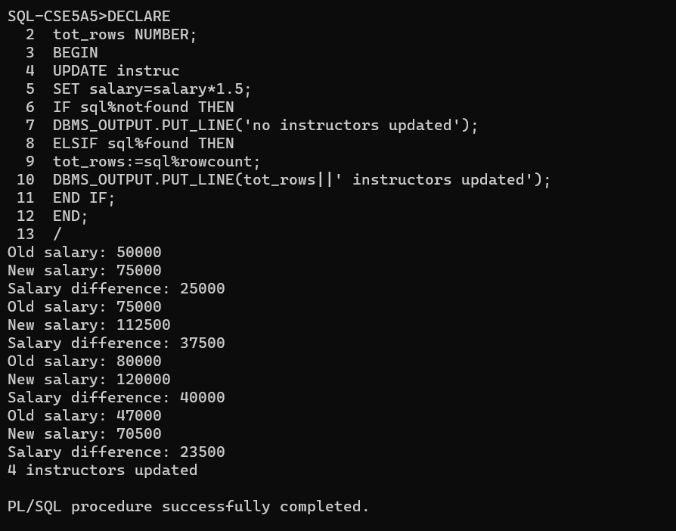

CONCLUSION:

PL/SQL program to implement Trigger on table is successfully completed.

EXPREMENT-16



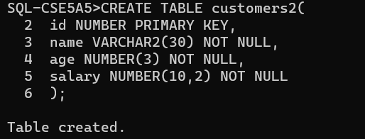

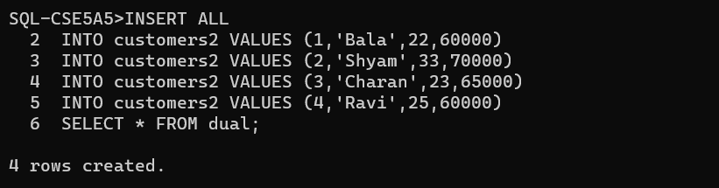

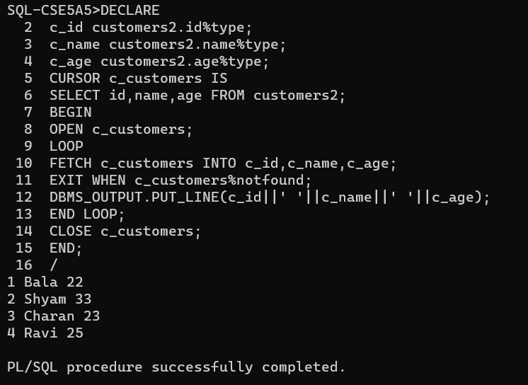

CONCLUSION:

PL/SQL program to implement Cursor on table is successfully completed.